Tab 1

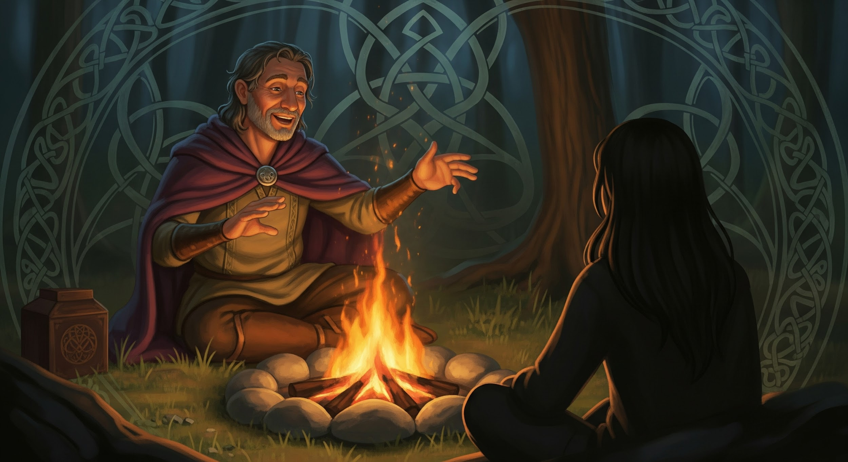

## **The Art of Storytelling: A Study Guide and Roadmap**

Storytelling is one of humanity’s oldest and most powerful tools. It carries memory, shapes identity, and builds bridges between people, cultures, and generations. Whether passed from mouth to ear in ancient gatherings or shared digitally across continents, stories remind us who we are — and who we might become.

### **Why Do We Tell Stories?**

At the heart of every story is a desire to connect.

From kitchen tables to communal fires, stories have always helped us express love, grief, pride, and defiance. In Ireland, this was embodied by the *Seanchaí* — keepers of memory and voice who could stir a crowd with a single line. Their stories preserved the spirit of a people when written language was outlawed or inaccessible.

Stories like *The Children of Lir* or tales of *Fionn mac Cumhaill* weren’t just entertainment; they were resistance. They passed on values, coded warnings, and joy across centuries of colonial erasure.

Even now, we tell stories to share lived experience, evoke empathy, and offer meaning in moments where facts alone can’t reach.

### **Forms of Storytelling**

#### **Spoken Word & Oral Tradition**

Long before books, there were voices in rooms. Storytelling through the spoken word — embellished with gesture, rhythm, and breath — was a deeply human way to hold and pass down wisdom. The Irish oral tradition excelled at this: a Seanchaí would use silence, tone, and eye contact like instruments, shaping memory into living performance.

#### **Monologue and Personal Recollection**

Some stories are quiet and deeply personal — a single voice remembering a moment that shaped them. Think of the way an Irish grandmother might begin, “I remember when…” and suddenly a kitchen fills with ghosts and ancestors. These private stories, though not staged, are still full of rhythm, pacing, and intimacy.

#### **Storytelling as Performance**

In many cultures, storytelling evolved into full-bodied performance — part theater, part ritual. Irish festivals like the *céilí* continue this tradition today, where tales are told with laughter, music, or even the beat of a *bodhrán* drum. A story isn’t just heard — it’s felt.

#### **Poetry and the Poetic Voice**

Irish poets (*filí*) were once revered as historians and seers. Through verse, they documented heroic battles, mourned lost loves, and challenged the status quo. A well-crafted poem tells a story in tight, vivid lines, using sound and image to carry meaning that lingers.

#### **Digital Storytelling and Multimedia Memory**

Today, storytelling continues in new forms — through animated myths, audio archives, and interactive exhibits. Irish folklore, once passed by whisper, is now found on websites and podcasts, reaching people who might never set foot in Ireland but still long to connect with their roots.

### **Performing the Story**

To speak a story aloud is to invite others into it.

Use your voice like an instrument. Let your hands dance with your words. Let silence stretch after a powerful line. This is something the Seanchaí knew well — their power was not in shouting but in holding the room’s breath. Pacing, pauses, even a raised eyebrow — all mattered.

A good storyteller reads the room. They know when to slow down, when to let the laughter build, and when to let a truth land softly, like fog, or hard, like a stone.

### **Becoming the Storyteller**

You have a story. The question is: how will you tell it?

#### **Start Here**

* **Find Your Spark** What moved you deeply? A challenge, a joy, a question that still lingers? Let this moment guide your story.
* **Shape the Journey** Every story needs a path — a beginning, middle, and end. But it doesn’t need to be linear. Trust what feels right.
* **Speak With Purpose** Practice aloud. In front of a mirror. To a friend. In the dark. Let the words live in your mouth before sharing them with others.

### **Where to Begin**

Find a local storytelling night or open mic. Attend an Irish language circle, a cultural center, or even a digital forum. Listen first — then speak. Storytelling is both a gift and a muscle. It grows when it’s used.