🧾 Instructions

🧾 Instructions: How to Use These Storytelling Cards
This is your story. You get to tell it your way.
These cards are here to help you think about what you want to say — and how you want to say it.
You can:
- 💬 Speak your story
- 🧠 Think about it quietly
- 👉 Point to a card
- ✍️ Write or draw on your own

🧩 What’s Inside
These cards are called Level Two — they help you go deeper.
- Finding My Spark
→ What matters to me? What do I want to talk about?
- Shaping the Path
→ I can choose how I tell it. There is no wrong way.
- Letting It Land
→ I can stop when I’m done. I don’t need to explain everything.

🧠 Tips
- You can use just one card, or all of them.
- You can take breaks any time.
- You can use the cards with a support person, if you like.

🙋‍♀️ You can say:
- “That’s the one I feel.”
- “I’m not ready yet.”
- “This is enough for now.”

🔐 You are in control.
You don’t have to finish.
You don’t have to share.
You don’t have to be ready.
Your story. Your way. Your pace.

Helping Someone Use the Storytelling Cards
Helping Someone Use the Storytelling Cards
These storytelling cards are tools to support self-expression. They are not worksheets, tests, or forms. Your role as a supporter is to create a safe space — not to direct, correct, or interpret.

🧭 Key Principles
1. Go Slow
Let the person take their time. There is no “right pace.”
2. Don’t Push for Detail
If someone wants to stop, move on, or be silent — that’s allowed.
3. Echo, Don’t Edit
If the person shares something, reflect it back gently. Don’t try to shape or fix it.
4. Pause With Purpose
Silence is okay. Processing takes time. Hold the moment without rushing.
5. Respect Boundaries
These cards may bring up emotion, memories, or vulnerability. Always ask permission before continuing or sharing.

💬 Helpful Prompts
- “Would you like to start with this one?”
- “You can just look at it — no need to talk yet.”
- “You don’t have to answer. You can just point.”
- “Do you want to keep going, or pause here?”

🔐 Protecting the Story
If someone shares something important or emotional, do not repeat it without permission — even with good intentions.
Stories are gifts. Treat them with care.

Finding my Spark
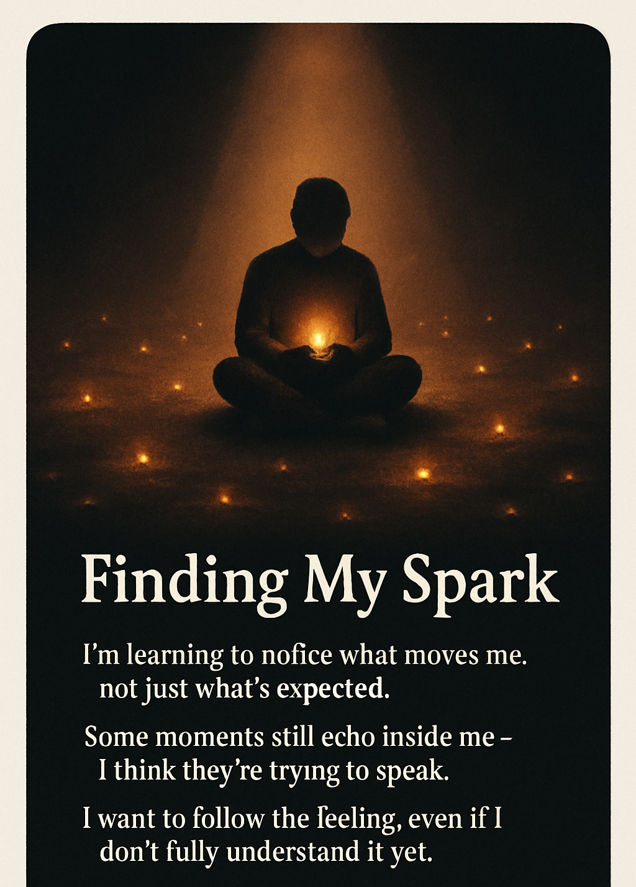

Shaping the Path
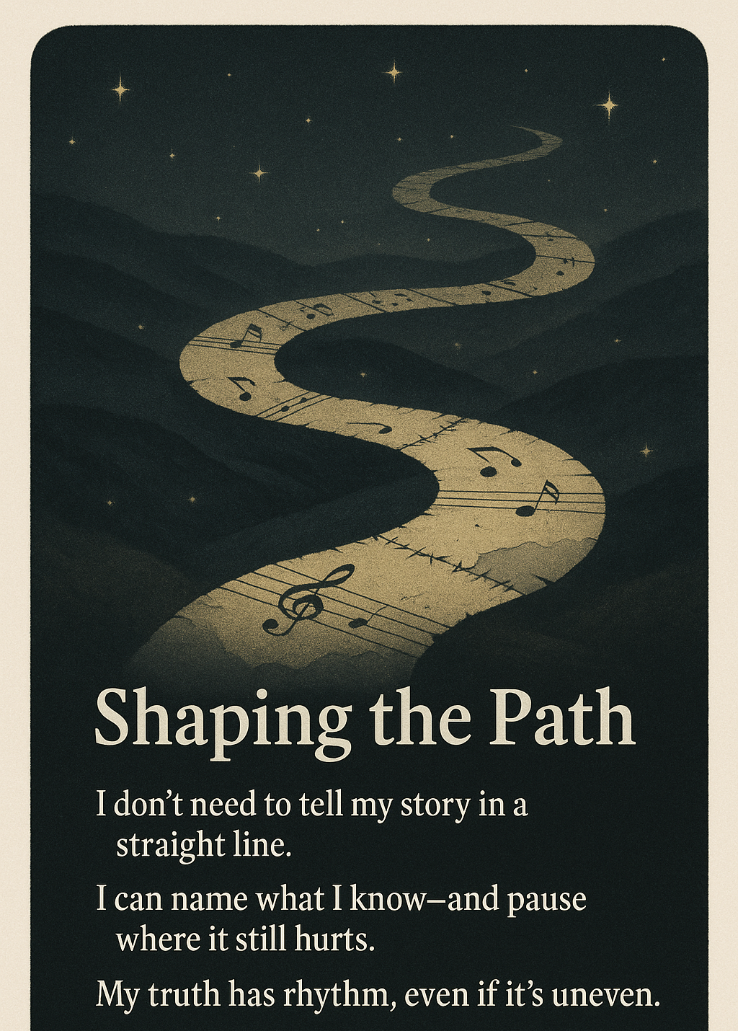

Letting it Land
